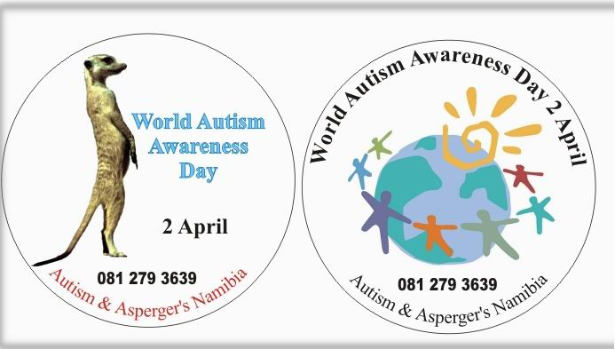

SHOW THAT YOU CARE ---------- BE AUTISM AWARE

MARCH & APRIL 2012: WORLD AUTISM DAY BADGES - DONATION N$3,00

The minimum donation per badge is N$3,00. Collect the funds and place your order (WORLD badge or MEERCAT badge) with Petra at 224561 or fax the order through to 228255, so that your badges may be collected / delivered. You may also order by email from the address above.

You may want to generate some funds for your school. Permission is hereby given to sell the badges at N$4,00 (N$3,00 for Autism & Asperger’s Namibia and N$1,00 for your SDF or tuck shop).

--------------------------------------------------

2 APRIL 2012: WORLD AUTISM DAY – LIGHT IT UP BLUE

Go civvies! Dress up in BLUE, or wear a BLUE hat; Light up your office, building or house in BLUE! Colour some white flowers BLUE (stand them in INKwater);

Initiated and driven by Autism Speaks USA, and supported by First Lady Penehupifo Pohamba. All donations collected in Namibia go towards the Namibian Autism Spectrum Research Project.

--------------------------------------------------

10 APRIL 2012: FILM – SNOWCAKE (language is English).

Venue: Goethe-Centre/NaDS, 1-5 Fidel Castro St, Windhoek – parking space available at the Centre

Start time: 19h15; Entrance fee: Adults N$30,00; Students N$10,00; Running time: approx 105 mins; Snacks & Drinks for sale.

A drama focused on the friendship between a high-functioning autistic woman and a man who is traumatized after a fatal car accident. With Sigourney Weaver, Alan Rickman and Carrie-Anne Moss.

--------------------------------------------------

18 APRIL 2012: FILM – GOETHE CENTRE: TEMPLE GRANDIN (language is English).

Venue: Goethe-Centre/NaDS, 1-5 Fidel Castro St, Windhoek – parking space available at the Centre

Start time: 19h15; Entrance fee: Adults N$30,00; Students N$10,00; Running time: approx 150 mins; Snacks & Drinks for sale.

A biopic of Temple Grandin, an autistic woman who has become one of the top scientists in the humane livestock handling industry. With Claire Danes, Julia Ormond and David Strathairn.

--------------------------------------------------

26 - 28 APRIL 2012: AUTISM SPECTRUM CONFERENCE & WORKSHOP
In Windhoek and Swakopmund
Theme: Treatment options for ASD. Several streams: For medical and healthcare practitioners, educationalists and parents. International and local speakers.
Please contact us for details: autnam@iway.na; Tel: 081 279 3639

--------------------------------------------------

YOUR SUPPORT ENSURES ONGOING TRAINING FOR PERSONS WORKING WITH CHILDREN WITH AUTISM.
This means that the children benefit directly.

For any information, brochures etc. about the projects or ASD, or our banking details, please do not hesitate to contact us. All donations and assistance gratefully accepted.

Every ONE contribution goes towards making a COLLECTIVE DIFFERENCE.

THANK YOU! TO OUR SPONSORS:

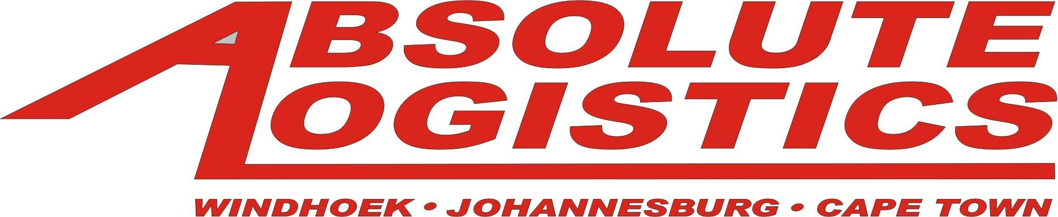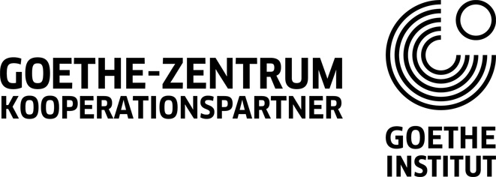
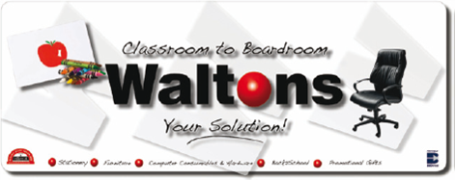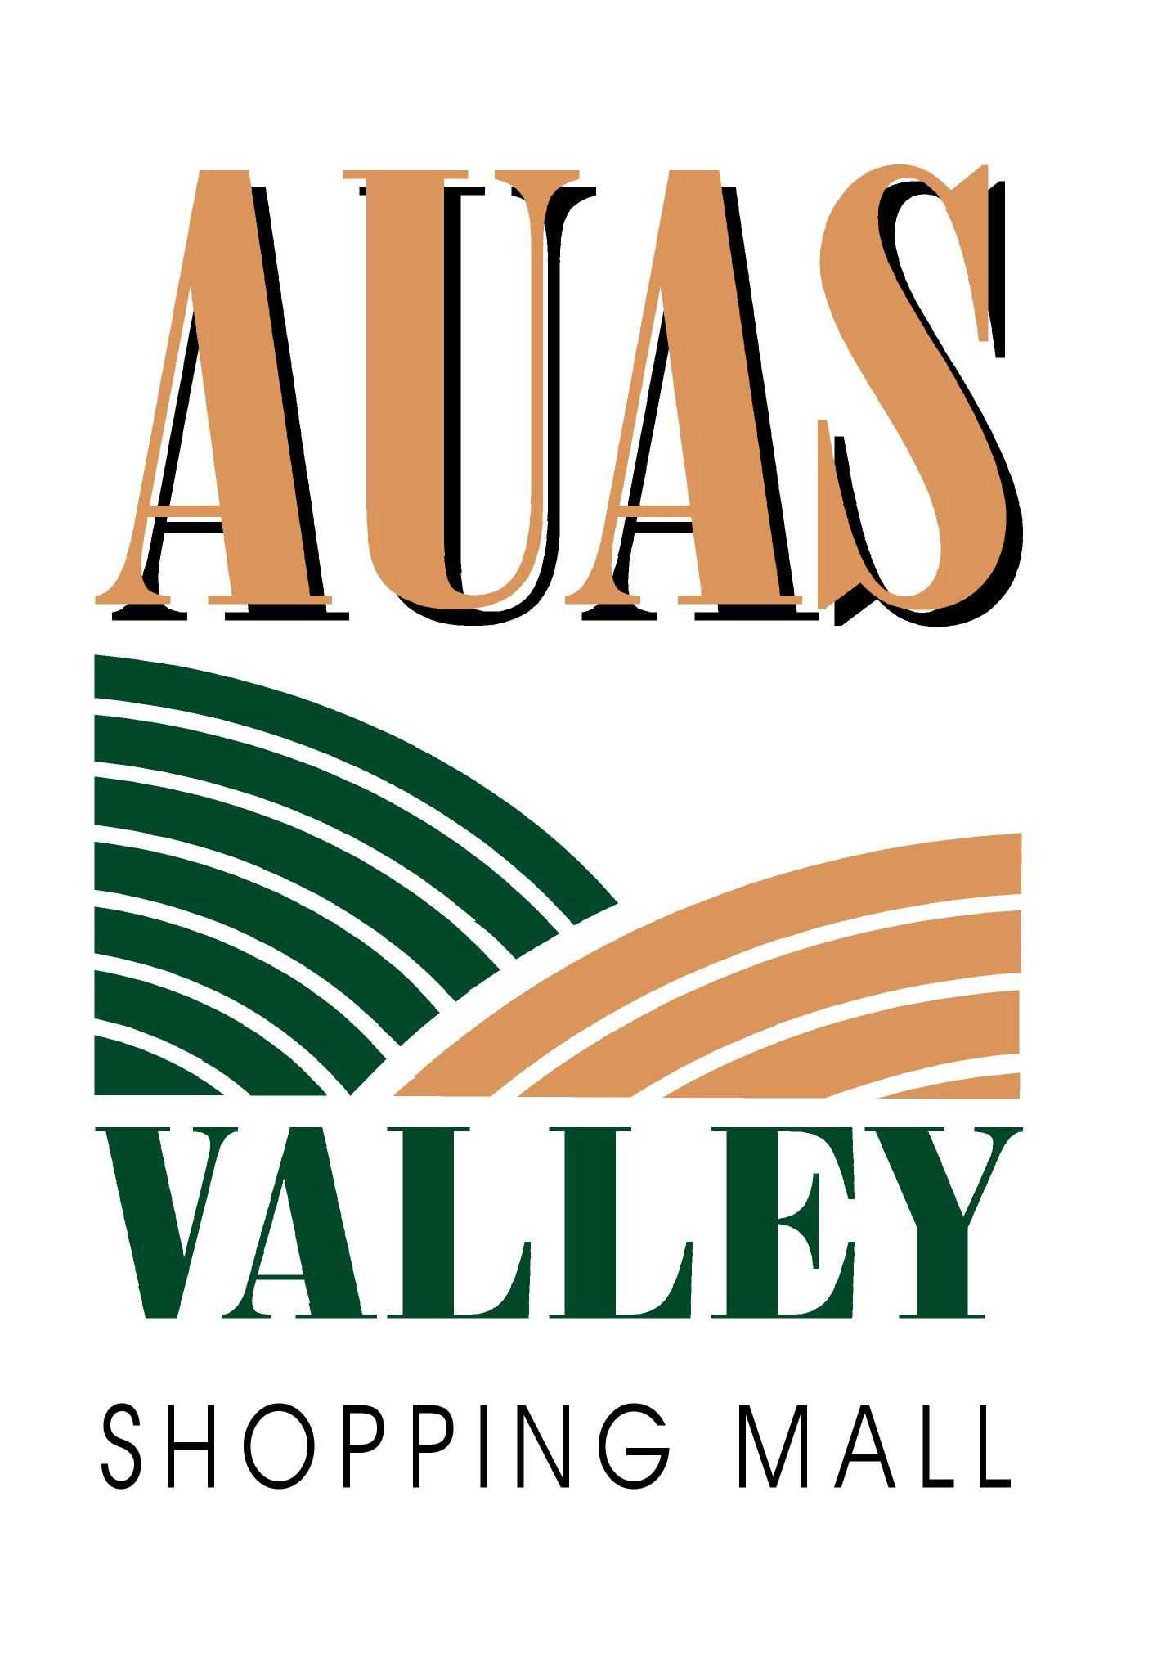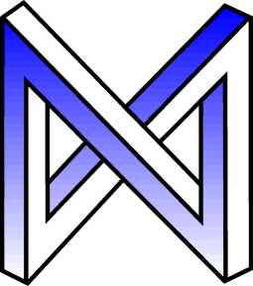
Müller & Neumeister Architects

ASD is a complex and variable developmental disability, which occurs as the result of disordered brain development and function, altering the child’s or person’s quality of development in the areas of communication, social interaction and imagination skills. ASD is found to be 4 times more common in boys than in girls, knowing no racial, ethnic, economic or social boundaries.
ASD manifests as a wide range of characteristics, presenting at different levels of severity. No two children or persons with autism are the same, so whilst you may find yourself comparing your child to another child with ASD, be aware that your child’s path of development will not necessarily be the same as for that child.

ASD is treatable but not curable. Structure, routine and training assist
greatly in reducing challenging behaviours, anxiety and
stress, and improve overall learning ability.

